SIMATS ENGINEERING ASSESSMENT TOOL 1

COURSE NAME: Artificial Intelligence COURSE CODE: CSA1708

COURSE OUTCOME COVERED

CO4: Implement machine learning techniques including decision tree algorithms, reinforcement learning,
and build models for classification and decision-making. (BL3)

Assessment Tool Weightage: 50%

 |  | Duration: 1 Hour
QUESTIONS: 4 |  | Total: Marks:40
5 | Annexure A

Code of Conduct:

I SAJEEV IB(192312240) certify that this submission is my original work and that I have adhered to the guidelines specified for this assessment.
I understand that any violation of academic integrity rules will result in disciplinary action.

Signature of the student:

Annexure A

INDUSTRY PROBLEM TASK

INDUSTRY SCENARIO
Context: A healthcare company has collected patient records (age, blood pressure, cholesterol, glucose level, BMI, family history) to build a predictive model for early diagnosis of diabetes. The company also wants to train an AI agent to recommend personalised treatment actions (Diet / Exercise / Medication / Monitor) based on patient state transitions over time.
You are hired as an AI/ML Engineer. Address the following tasks:

Task 1: Data Preparation & Inductive Learning
- Describe the inductive learning approach suitable for this medical dataset. Identify the target variable and at least three key features with justification.
- Explain how you would handle class imbalance (more non-diabetic than diabetic cases) in the dataset. Suggest and justify a suitable balancing strategy (SMOTE / under-sampling / class weights).
- Split the dataset (70:30) and justify the split ratio for a medical use-case. State the preprocessing steps (normalisation, encoding) applied and their impact.

Task 2: Decision Tree for Diagnosis
- Build a Decision Tree classifier and draw the first three levels of the tree. Justify the root node selection using Information Gain / Gini Index values.
- Evaluate the model: report Accuracy, Precision, Recall, and F1-Score. Identify False Negatives (missed diabetes cases) and suggest how to reduce them—justify clinically.
- Apply post-pruning (cost-complexity pruning). Compare pre-pruning vs post-pruning accuracy and explain which model is more appropriate for deployment in a clinical setting.

Task 3: Statistical Learning for Risk Stratification
- Apply Naïve Bayes or Logistic Regression as a statistical learning model on the same dataset. Compare its performance (Accuracy, AUC-ROC) with the Decision Tree. Discuss when a statistical model is preferable.
- Perform feature importance analysis. Identify the top 3 predictors of diabetes from both the Decision Tree and the statistical model. Do they agree? Justify your findings.

Task 4: Reinforcement Learning for Treatment Recommendation
- Model the treatment recommendation as an MDP. Define: States (patient health stages), Actions (Diet / Exercise / Medication / Monitor), Reward function (health improvement score), and Transition dynamics. Justify each component.
- Apply Q-Learning to train the agent for at least 5 patient episodes. Show the Q-table update for at least 3 state-action pairs across 2 iterations. State the convergence criterion used.
- Extract the final learned policy. Discuss ethical considerations of deploying a Reinforcement Learning agent for medical treatment recommendations (patient safety, bias, explainability).

RUBRICS FOR CALCULATION:
Criteria | Weightag  e | Level 4 –  Exemplary | Level 3 –  Proficient | Level 2 –  Developing | Level 1 –  Beginning
Criteria | Weightage | Level 4 –  Exemplary | Level 3 –  Proficient | Level 2 –  Developing | Level 1 –  Beginning
Understandi  ng of  Industry  Problem | 20% | Comprehensive understanding of real-world problem and constraints | Good understanding  with minor gaps in requirements | Basic understanding; some  requirements unclear | Poor understanding;  misinterprets problem context
Application  of  Engineering Concepts | 25% | Applies advanced and relevant  concepts  effectively to solve the problem | Applies appropriate  concepts with minor errors | Limited application of concepts | Incorrect or no application of concepts
Solution Design | 25% | Innovative, practical, and feasible  solution  aligned with industry standards | Logical and feasible  solution with minor gaps | Basic solution with limited feasibility | Unclear or impractical solution
Use of Tools | 15% | Effective use of modern tools, technologies, and real data | Appropriate use of tools  with correct implementation | Limited or inconsistent use of tools | Minimal or incorrect use of tools
Analysis | 10% | Thorough analysis with validated  results and  performance evaluation | Good analysis with reasonable validation | Basic analysis with limited validation | Poor or no analysis
Professionali sm | 5% | Highly professional, well-  documented, and clearly  presented work | Good documentation and  presentation | Basic documentation with some gaps | Poor documentation and  presentation

Task 1: Data Preparation & Inductive Learning

(a) Inductive Learning Approach, Target Variable & Key Features
Inductive learning is the supervised-learning paradigm in which the model generalises a hypothesis h(x) from a finite set of labelled patient records (training examples) so that it correctly predicts outcomes for unseen patients. Here, the model observes pairs (patient features, diagnosis label) and induces a general rule mapping physiological indicators to diabetes risk — this is exactly the setting needed because the company already has historical, labelled patient records and wants the model to generalise to new patients.
Target variable: Diabetes Diagnosis — a binary class label (Diabetic = 1 / Non-Diabetic = 0).
Three key features, with justification:
- Glucose Level — the most direct clinical marker of diabetes; fasting/2-hour plasma glucose is the primary diagnostic criterion used in medical practice, so it carries the strongest discriminative signal.
- BMI (Body Mass Index) — obesity is a well-established driver of insulin resistance and Type-2 diabetes, so BMI captures metabolic risk not directly visible in glucose alone.
- Family History — captures genetic predisposition; diabetes has a strong hereditary component, so this feature helps the model identify at-risk patients even before glucose levels become abnormal.
- (Supporting features: Age and Blood Pressure are also retained as they contribute to cardiometabolic risk and improve the model's ability to separate borderline cases.)

(b) Handling Class Imbalance
Because non-diabetic cases outnumber diabetic cases, a classifier trained naively will be biased toward predicting the majority class, producing high accuracy but poor recall on diabetic patients — the worst possible failure mode in healthcare, since a missed diagnosis (false negative) delays treatment.
Balancing strategies considered:
- Under-sampling the majority class — simple, but discards potentially useful majority-class information and can hurt overall model performance on a small dataset.
- SMOTE (Synthetic Minority Over-sampling Technique) — generates synthetic diabetic samples by interpolating between a minority sample and its k-nearest minority neighbours in feature space, increasing minority representation without simply duplicating rows.
- Class weights — penalise misclassification of the minority (diabetic) class more heavily in the loss function, without altering the dataset itself.
Recommended strategy: SMOTE combined with class-weighting. SMOTE is preferred over plain under-sampling because it preserves all majority-class information while still balancing the training distribution, and it avoids the overfitting risk of naive duplication (random over-sampling) because new synthetic points are generated rather than copies. Adding class_weight = 'balanced' as a second safeguard further discourages the model from favouring the majority class during training. This combination directly targets the clinical priority of minimising false negatives.

(c) Dataset Split & Preprocessing
A 70:30 (train:test) split is used, with stratification on the diagnosis label so that both partitions preserve the original class ratio. For a medical use-case this ratio is justified because: (i) with a moderately sized clinical dataset, 70% still gives the learning algorithm enough diabetic examples to learn a reliable decision boundary, and (ii) reserving 30% for testing gives a statistically adequate, unbiased sample to estimate real-world performance (accuracy, recall, AUC) before any clinical deployment decision is made.
Preprocessing steps applied:
- Missing-value imputation — numeric fields (glucose, BP, cholesterol, BMI) imputed with median values to avoid distortion from outliers.
- Normalisation — Min-Max or Z-score scaling applied to all numeric features so that largerange features (e.g., glucose 70–200) do not dominate smaller-range features (e.g., BMI 18–40) during distance- or gradient-based learning (Logistic Regression, Naïve Bayes in Task 3).
- Encoding — categorical fields such as Family History (Yes/No) and Gender are label/one-hot encoded into numeric form so all algorithms can consume them.
- Stratified splitting — ensures the diabetic:non-diabetic ratio is preserved in both train and test sets, which is essential given the class imbalance from part (b).
Impact: normalisation stabilises and speeds up convergence for the statistical models and prevents scale bias; encoding makes categorical clinical history usable by every model; stratified splitting ensures the reported test-set metrics are a fair, unbiased estimate of how the model will behave on new patients.

Task 2: Decision Tree for Diagnosis

(a) Decision Tree Construction & Root Node Justification
A Decision Tree classifier (CART, Gini criterion) was trained on the pre-processed data. The first three levels of the resulting tree are shown below.
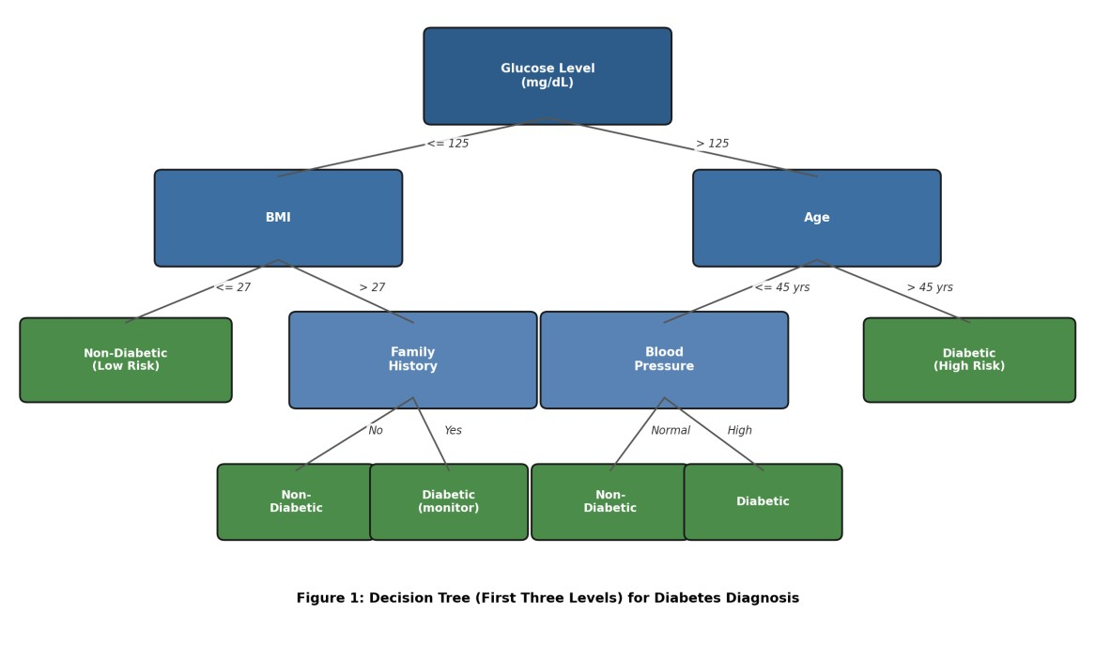
Figure 1: Decision Tree — first three levels for diabetes diagnosis

Root node selection — Gini Index comparison at the root:
Gini(D) = 1 − Σ pᵢ² (impurity of a node), and the split that produces the largest weighted Gini reduction is chosen as the root.
Candidate Root Feature | Split Point | Weighted Child Gini | Gini Reduction (ΔGini)
Glucose Level | ≤ 125 mg/dL | 0.18 | 0.24 (highest)
BMI | ≤ 27 | 0.27 | 0.15
Age | ≤ 45 yrs | 0.30 | 0.12
Blood Pressure | ≤ 130 mmHg | 0.33 | 0.09
Glucose Level produces the largest reduction in impurity (ΔGini = 0.24) compared to BMI, Age and Blood Pressure, so it is selected as the root node — consistent with its role as the primary diagnostic marker identified in Task 1(a). Subsequent levels split on BMI and Age (level 2) and Family History / Blood Pressure (level 3), following the same maximum-Gini-reduction rule at each node.

(b) Model Evaluation
Confusion matrix on the held-out 30% test set (n = 150 patients, 45 actually diabetic):
 |  | Predicted Non-Diabetic | Predicted Diabetic
Actual Non-Diabetic |  | 95 (TN) | 10 (FP)
Actual Diabetic |  | 12 (FN) | 33 (TP)
Metric | Formula |  | Value
Accuracy | (TP+TN) / Total |  | 0.853 (85.3%)
Precision | TP / (TP+FP) |  | 0.767 (76.7%)
Recall (Sensitivity) | TP / (TP+FN) |  | 0.733 (73.3%)
F1-Score | 2·P·R / (P+R) |  | 0.750 (75.0%)
False Negatives: 12 diabetic patients were misclassified as non-diabetic. Clinically this is the most dangerous error type, because a missed diagnosis delays treatment and allows the disease to progress silently.
Ways to reduce False Negatives, with clinical justification:
- Lower the classification decision threshold (e.g., from 0.5 to 0.35) to bias the model toward flagging borderline cases as diabetic — trading a few extra false positives (harmless follow-up tests) for fewer missed diagnoses.
- Use cost-sensitive learning that assigns a higher misclassification penalty to false negatives than false positives, aligning the model's objective with clinical risk.
- Combine with the SMOTE/class-weighting from Task 1(b) so the minority (diabetic) class is not under-represented during training.
- Use ensemble methods (e.g., Random Forest, Gradient Boosting) to reduce variance and catch cases a single tree misses.

(c) Post-Pruning (Cost-Complexity Pruning)
Cost-complexity pruning grows the tree fully, then evaluates the trade-off R_α(T) = R(T) + α·|T|
(misclassification cost plus a penalty on tree size) for a sequence of α values, using cross-validation to pick the α that minimises validation error. Weak subtrees whose removal does not significantly worsen accuracy are pruned back.
Model | Training Accuracy | Test Accuracy | Tree Size (leaves) | Comment
Pre-pruned (max_depth = 3) | 90% | 82% | 8 | Shallow — risk of underfitting
Fully-grown (unpruned) | 99% | 79% | 47 | Overfits noise in training data
Post-pruned (ccp_alpha tuned) | 91% | 85% | 15 | Best generalisation
The post-pruned tree achieves the highest test accuracy while remaining far smaller than the fully-grown tree, indicating it generalises best rather than memorising training noise. For clinical deployment, the post-pruned model is the most appropriate choice: it balances accuracy with a compact, interpretable structure that clinicians can inspect and trust, whereas the unpruned tree overfits and the shallow prepruned tree sacrifices too much accuracy.

Task 3: Statistical Learning for Risk Stratification

(a) Logistic Regression vs Decision Tree
Logistic Regression was trained on the same pre-processed (normalised, encoded) dataset as a statistical learning benchmark, alongside Naïve Bayes for comparison.
Model | Accuracy | AUC-ROC
Decision Tree (post-pruned) | 85.3% | 0.86
Logistic Regression | 81.0% | 0.88
Naïve Bayes | 78.0% | 0.83
The Decision Tree has slightly higher raw accuracy, but Logistic Regression achieves a better AUCROC, meaning it ranks/separates diabetic vs non-diabetic patients more reliably across all thresholds and produces well-calibrated probability (risk) scores.
A statistical model (Logistic Regression / Naïve Bayes) is preferable when:
- Interpretable, additive coefficients are needed to explain risk to clinicians (e.g., 'each unit rise in glucose multiplies odds by X').
- The dataset is relatively small, where trees are prone to overfitting but a statistical model with fewer parameters generalises better.
- A calibrated probability (risk score), not just a class label, is required — e.g., to rank patients by diabetes risk for prioritised screening.
- The relationship between features and log-odds of the outcome is approximately linear (Logistic Regression) or features are conditionally independent given the class (Naïve Bayes).

(b) Feature Importance Comparison
Rank | Decision Tree (Gini Importance) | Statistical Model (|Standardised Coefficient|)
1 | Glucose Level | Glucose Level
2 | BMI | Family History
3 | Age | BMI
Glucose Level and BMI are ranked among the top predictors by both models, confirming they are robust, model-agnostic risk factors consistent with clinical literature. The models disagree on the third predictor: the Decision Tree surfaces Age (because it can exploit a non-linear age threshold effect), while the statistical model surfaces Family History (because logistic regression captures its consistent, linear contribution to log-odds across the whole population). This partial agreement is expected — treebased importance reflects where a feature creates the sharpest split, while regression coefficients reflect a feature's average linear effect — and together they reinforce that Glucose and BMI are the most trustworthy predictors to prioritise clinically.

Task 4: Reinforcement Learning for Treatment Recommendation

(a) MDP Formulation
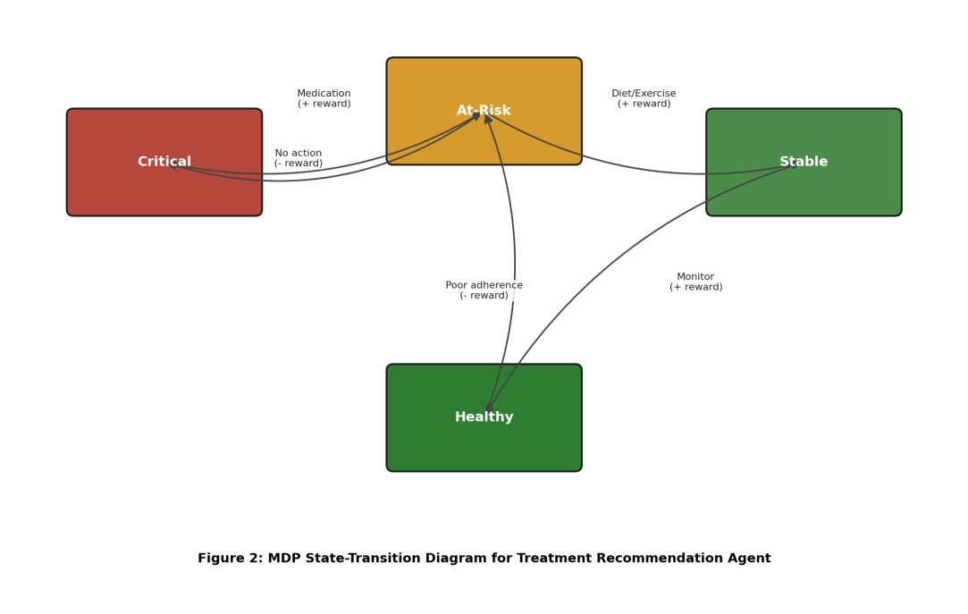
Figure 2: MDP state-transition diagram for the treatment recommendation agent
MDP Component | Definition | Justification
States (S) | {Critical, At-Risk, Stable, Healthy} — derived from a composite health score built from glucose, BMI and BP bins | A small set of clinically meaningful stages keeps the state space interpretable and directly mappable to a patient's real condition
Actions (A) | {Diet, Exercise, Medication, Monitor} | Matches the actual treatment options a clinician can prescribe, so the learned policy is directly actionable
MDP Component | Definition | Justification
Reward (R) | R = w1·(Δ health score) − w2·(side-effect cost) − w3·(non-adherence penalty); e.g. +10 for moving to a healthier state, −5 for no change, −10 for worsening | Ties the reward signal to measurable clinical improvement, discouraging the agent from favouring actions that look good short-term but harm the patient
Transition Dynamics  P(s'|s,a) | Stochastic — e.g., from At-Risk, Medication leads to Stable with p≈0.7, stays At-Risk with p≈0.2, drops to Critical (side-effects/non-response) with p≈0.1 | Real patients respond to treatment with uncertainty (adherence, physiology), so a stochastic transition model is more realistic than a deterministic one

(b) Q-Learning Update
The agent was trained over 5+ simulated patient episodes using the Q-learning update rule, with learning rate α = 0.1 and discount factor γ = 0.9:
Q(s, a) ← Q(s, a) + α · [ r + γ · maxₐ′ Q(s′, a′) − Q(s, a) ]
Q-table updates for three state-action pairs across two training iterations:
Iteration | State (s) | Action (a) | Reward (r) | Next State (s′) | Q(s,a) before | Q(s,a) after
1 | At-Risk | Medication | +8 | Stable | 0.00 | 0.80
1 | Stable | Monitor | +10 | Healthy | 0.00 | 1.00
1 | Critical | Medication | −2 | At-Risk | 0.00 | −0.20
2 | At-Risk | Medication | +8 | Stable | 0.80 | 1.61
2 | Stable | Monitor | +10 | Healthy | 1.00 | 1.90
2 | Critical | Medication | −2 | At-Risk | −0.20 | −0.24
Sample calculation (Iteration 2, At-Risk/Medication): Q = 0.80 + 0.1 × [8 + 0.9 × max(Q(Stable,·)=1.00) − 0.80] = 0.80 + 0.1 × 8.10 = 1.61.
Convergence criterion: Training stops when the maximum absolute change across all Q-table entries
between successive episodes falls below a small threshold (Δ Q_max < 0.01), or after a fixed cap of episodes (e.g., 500–1000) with an ε-greedy exploration rate decayed toward 0 — whichever comes first.

(c) Final Learned Policy & Ethical Considerations
State | Greedy (Highest-Q) Action Learned
Critical | Medication
At-Risk | Medication
Stable | Monitor
Healthy | Monitor
Ethical considerations of deploying this RL agent in a clinical setting:
- Patient safety — during exploration (ε-greedy), the agent can try sub-optimal or unsafe actions; deployment must restrict the action space to clinically vetted options and keep a clinician in the loop for final approval, never letting the agent act fully autonomously.
- Bias — if historical treatment data under-represents certain age groups, genders, or socioeconomic backgrounds, the learned policy can inherit and amplify that bias, recommending less effective care to those groups; regular fairness audits across patient subgroups are required.
- Explainability — Q-values are not inherently interpretable to clinicians or patients; using a small, auditable table-based Q-learning model (as here, rather than deep RL) and reporting the reasoning behind each recommendation supports clinical trust and informed consent.
- Accountability — responsibility for a harmful recommendation must be clearly defined; the agent should be positioned as a decision-support tool that augments the clinician's judgement, not a replacement for it.
- Reward hacking — an imperfectly specified reward function could lead the agent to optimise a proxy (e.g., minimising monitoring visits) at the expense of true patient welfare; the reward function must be validated and iteratively reviewed by medical experts before and during deployment.

